VSS Guidelines



Revision History

Version Number | Creation/  Revision Date | Prepared /Updated By | Reviewed By | Approved By | Change Description
1.0 | 14.06.2023 | Rajashree M. | Jayanta C. | Jayanta C. | Baseline version

Table of Contents

1. Introduction 4
1.1 Purpose 4
1.2 Scope 4
1.3 Definitions and Abbreviation 4
2. VSS usage for configuration management of development 4
2.1 Check out process 4
2.2 Updating of files 10
2.3 Conflict Resolution 11
2.4 Tagging 12
2.5 Steps to create a branch 14
2.6 Using Tags as Version Control 14
2.7 Using Branches as Concurrent Development Environment 15
2.8 Two Tag Merge 15
2.9 Baselining Process 19

Introduction
Configuration – Literal meaning: Arrangement, Assembling.The process of identifying, organizing and controlling changes to the software during the life cycle of a project

Purpose
The purpose of Configuration Management (CM) is to establish and maintain the integrity of work products using configuration control.

The Configuration Management process area involves the following activities

- Identifying the configuration of selected work products that compose baselines at given points in time
- Controlling changes to configuration items
- Maintaining the integrity of baselines
- Providing accurate status and current configuration data to developers, end users, and customers.

The work products placed under configuration management include the products that are delivered to the customer, designated internal work products and tools used in maintaining the CM.

Scope
The scope of this guideline document is applicable to all the projects that use VSS as a tool for configuration management.

Definitions and Abbreviation
VSS Concurrent version system
CM Configuration Management

VSS usage for configuration management of development

Check out process
Checkout Process needs to be done only once (Usually).

When checkout is done, a local “sandbox” is created.
A copy of the source code is maintained in the local system.
Any changes done locally, VSS gives the status as “Locally Modified”.
Any Changes done at the server (i.e. by somebody else doing a commit) will not be reflected in the local copy.

The local copy is specific to the developer who has checked out the files.

1.1 Click the highlighted area

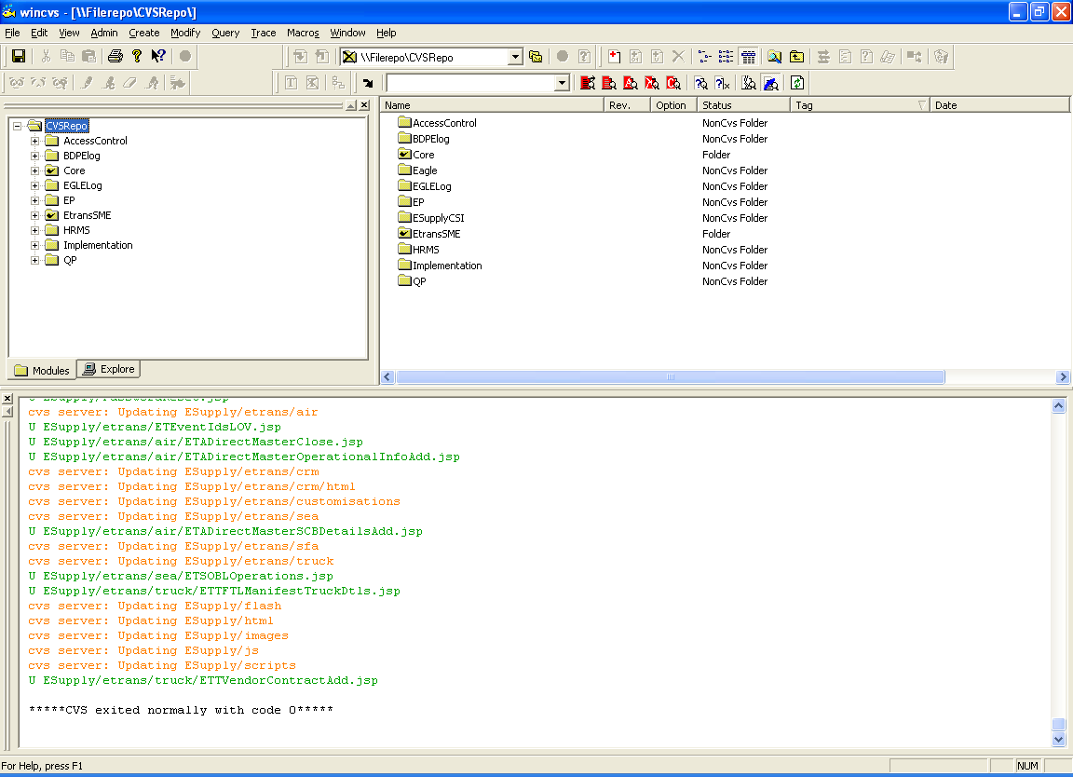

You will get a browse window

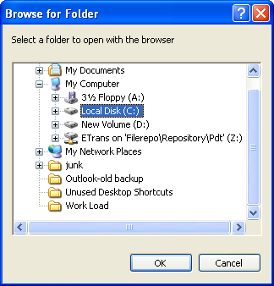

Locate the VSSroot
Eg. \\filerepo\CVSRepo

Click OK.

This will be saved as preferences and will appear in the drop down list box, so that you need not select the VSSRoot again.

To Checkout, you need to know from where the files have to be checked out

Right click on any folder on the left hand side (the directory structure)

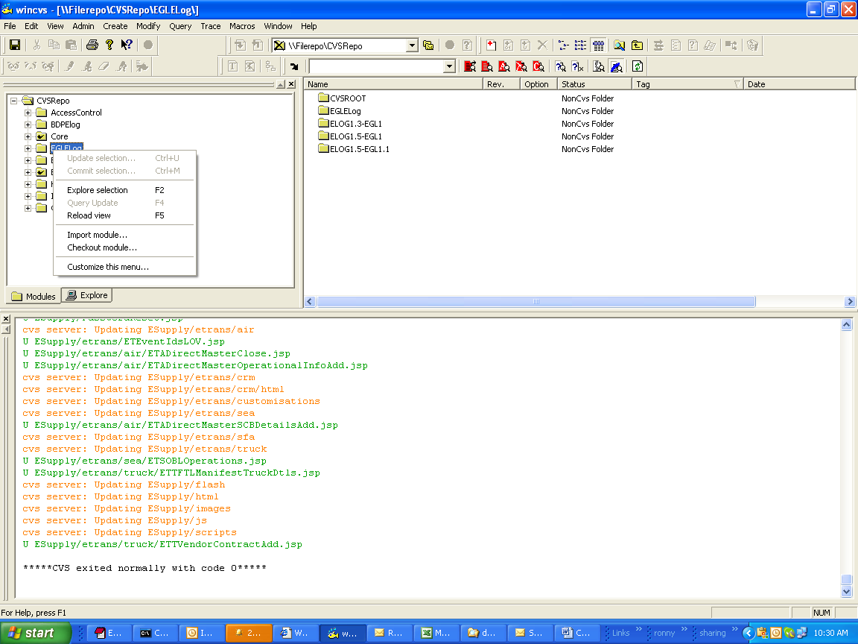

Select “Checkout Module”

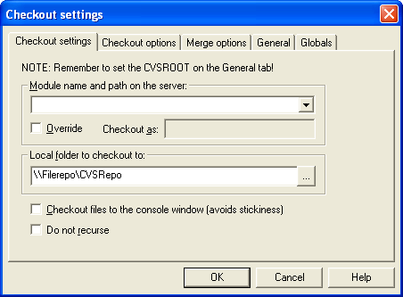

“Module name and path on the server”
Here you need to mention the path on the server.
This will NOT be the absolute path, but the path relative to the configuration done in STEP 1.

“Local folder to checkout to”
Mention the local folder to check out.
Click “override” and mention the directory name (use this if the server path is too long)

By doing this the Complete server directory structure will not be created locally. But it will be replaced by the single directory name that you mention here.
Eg the server path is version1.8\source code\ development\source\project\product…

While checking out, you need to decide whether the “ROOT” version has to be checked out, or the checkout needs to be done from a “Branch” or a “Tag”

Click on “Checkout Options”
You will get the following input screen
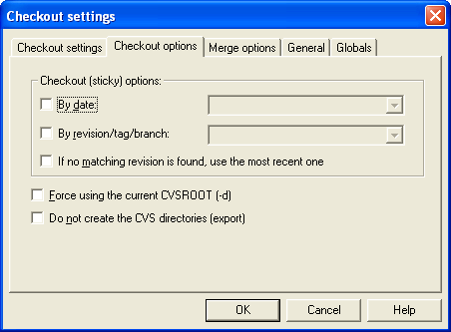

a.
If you need to checkout the files as on a particular date
Select “By Date”
b.
If you need to checkout the files from particular branch / tag
Select “By revision/tag/branch”
NOTE: Both options can be selected, and checkout can be done.
Suppose, development has started on 5th January 2009 on a branch named “AFL_12” and the current date is May 27th 2009.
If you want to retrieve files as on May 27th 2009, on this branch, then you can select both the checkboxes and enter the details appropriately
c.
Apart from checking out a file from a branch or date, you can tell VSS to merge changes done between two branches, tags or dates!! (Complex requirement!!)

E.g.
There are 2 features getting developed in 2 different branches say Feature_1, Feature_2
You need to checkout the Feature_1 files and MERGE the changes done in Feature_2 into the checked out files

Then you need to specify the “Feature_1” branch name in the “Checkout Options”
And click “Merge Options”
You will get the following input screen.

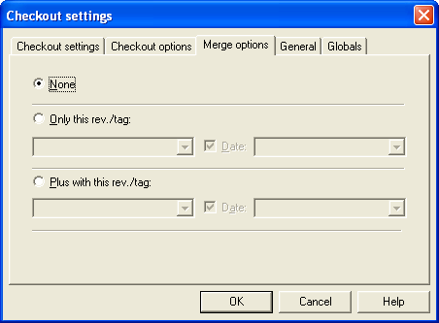

Click on “Only this rev/tag”, and enter “Feature_2”

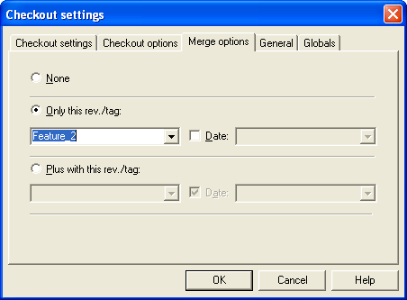

By doing this, you are telling VSS to checkout the files from branch “NewFeature_1” and merge all changes done in the “NewFeature_2” branch.

This is possible on if both the branches are created from the same “ROOT”

“ROOT” is the version that is first imported in CVS.

Updating of files

Types of Update:-

- Normal Update (Applicable to directory / file)
- Clean Update (Applicable to directory / file)
- Update for new files (Applicable to directory only)
- Update to a specific Version (Applicable to directory only)
- Adding or Deleting File

Normal Update (Applicable to directory / file)
Local changes done in the file is retained.
Any changes in the repository will be merged
This update may give a conflict.
New files added to the repository will not be downloaded

Clean Update (Applicable to directory / file)
Local changes done in the file are lost.
The latest file will be downloaded to the local system.
This update will never give an error.
New files added to the repository will not be downloaded

Update for new files (Applicable to directory only)
Any new files created will also be downloaded
This is an additional option used while updating
This is done simultaneously with Clean / Normal update

Update to a specific Version (Applicable to directory only)
This is an additional option used while updating
This is done simultaneously with Clean / Normal update
If Clean Update is selected then the specific version will be downloaded.
Local changes will be lost

Adding or Deleting File
New file can be added or existing file can be deleted by selecting (placing) the respective file from appropriate folder and clicking the icons as shown in the below figure.
Please note that, adding or deleting of files should be done through approvals from respective Managers.

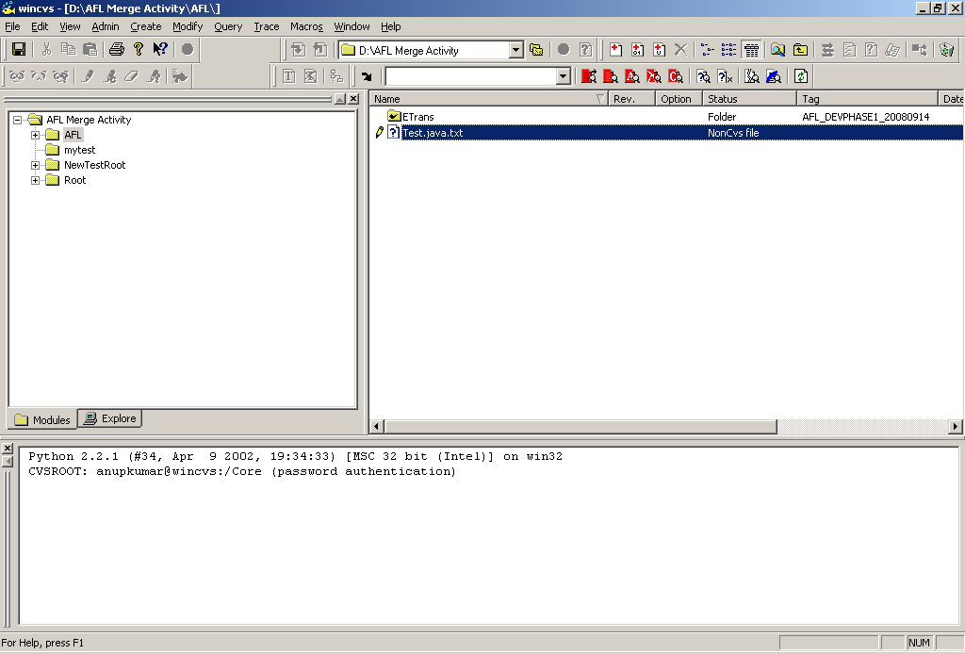

Conflict Resolution

Whenever a “Normal” update is done, 2 things can happen.
a. The Changes are merged
b. There is conflict reported by CVS

In case of Merge, the win VSS Client will display the file as if it has changed. (Red color)
In case of conflict VSS will append the conflicted lines in the files. It is very important to resolve the conflicts before committing the file back to CVS.

Whenever conflicts are reported by CVS

It automatically adds the following lines in the source code

<<<<<<<<<<
// some lines of code
= = = = = = = (this is actually equal to sign)
// some lines of code
>>>>>>>>>>

You need to remove the 3 extra lines added by VSS and either retain the lines of code as per the functionality required.
This activity of removing the extra lines added by VSS and retaining the required lines of code is called as “Conflict Resolution”.

Tagging

Tag is a symbolic reference name to mark the state of files at a point in time.

Suppose the first import was done on 15th Dec 2009. On 25th Dec the source code was given to QA for 1st Round of FAT.
You can create a tag, called version_2_5_ReleaseToQA_FAT_Round1

You can then check out the code based on this tag, which will be the same as which was given to QA. This is sort of Baselining the code.

Steps to create a tag:

Select the folder where the tag is to be created

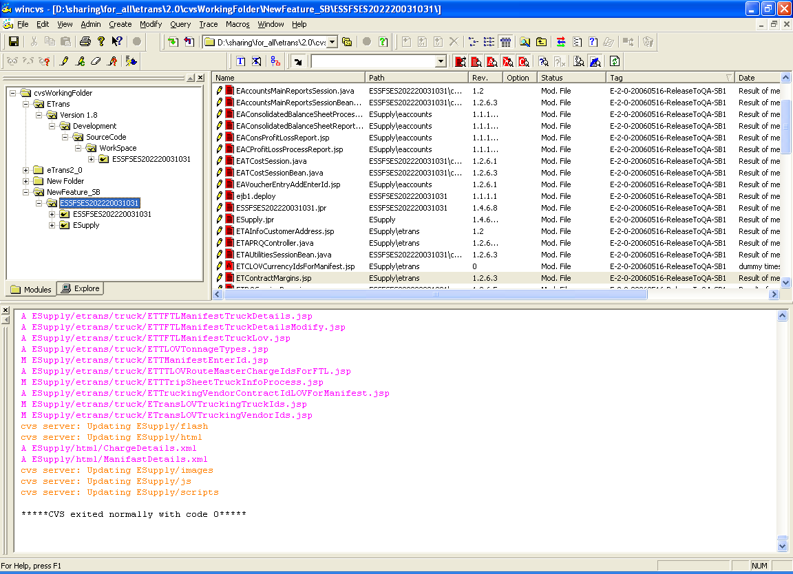

Click on the Icon as shown below

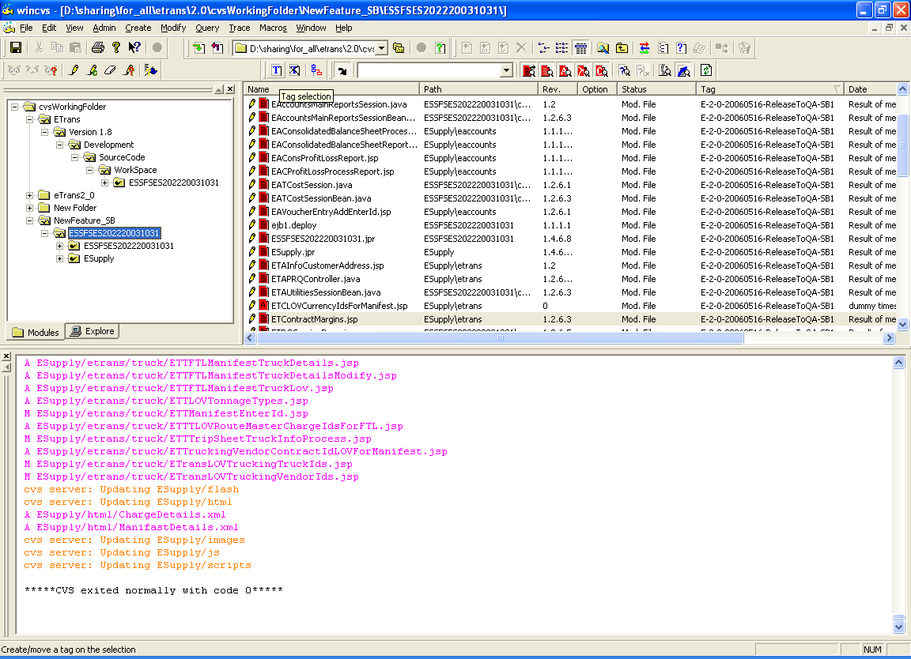

You will see the following window

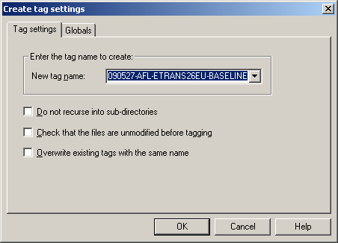

Enter the name of the tag that you want to create.

Click OK.

All the files in the directory will be tagged with the name that you enter.

Steps to create a branch

Same as tagging, but a different icon is present for that.

On click of the Branch icon you will get the following screen

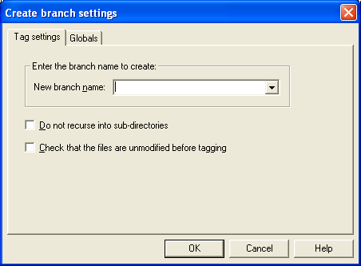

Enter the branch name.

Click OK.

Using Tags as Version Control

Two tag merge is a process where concurrent development happens in 2 separate branches, and the changes in one of the branches need to be reflected in another branch.

e.g.: consider the case of UI Related changes.

The requirement is that new functionality needs to be added in the application, and parallel GUI Related changes also should happen.

The functionality changes have to be released first and the UI change at a later point in time.
Ideally it is better to finish off with the Functionality changes and then go ahead with the UI Changes in a sequential manner. But the development effort of UI Changes is large and both the tasks have to be started with immediate effect.

In such a scenario VSS helps us in managing the 3 separate source codes and parallel development can start without overlapping changes of one feature and another feature.

Using Branches as Concurrent Development Environment

Root Source
|
|------- Functionality_Branch
|
|------- UI_Branch

As depicted above, you can create 2 branches one called “Functionality_Branch” and other called “UI_Branch”

This means, we are actually creating 2 separate source code base.
Some developers will checkout the UI_Branch and start making changes, and another group can checkout from the Functionality_Branch and make changes.

Over a period of time different sets of files will be changed in both the branches. Since the Functionality_Branch will be released first and then the UI Changes, All changes done in the Functionality_Branch must be reflected in the UI_Branch.

Two Tag Merge

This can be achieved in VSS by the 2 Tag Merge Method.
To do a 2 tag merge process the initial step is a single tag merge

Steps to do the Single tag method merge.
Checkout the branch from which changes has to be done. In our case it is the Functionality_Branch
Create a tag say MergeWithUI05April2006 to mark the files.
Checkout the branch, where the changes have to be done. In our case it is the UI_Branch
Create a tag say BeforeMergeWithFunctional05April2006. This step can be avoided, but in case anything goes wrong while merging (lost connection / hang etc.) the source code of UI Changes can be easily retrieved using the Tag name.
Update the root folder with Merge option as MergeWithUI05April2006

(Screen displaying the update option)

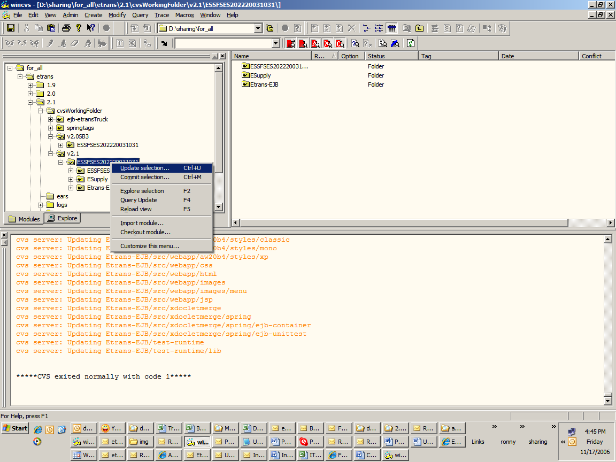

(On click of update you will the following screen)

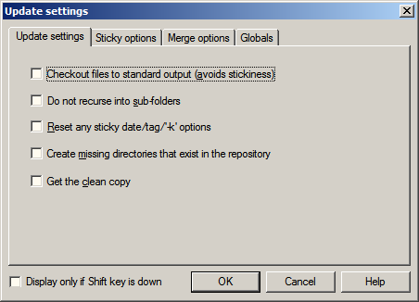

Select “Merge options” tab
(You will see the following screen)

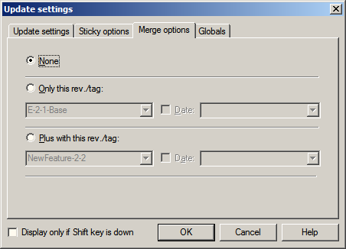

Select “Only this rev. /tag” and enter the created tag name i.e. “MergeWithUI05April2006”

(Screen depicting the entered tag name)

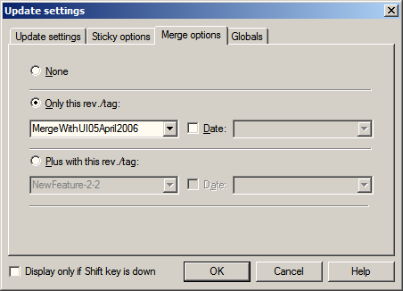

Click Ok

All the changes done in Functionality branch will be merged in the UI Branch.

Resolve the conflicts and commit the files.

Subsequently we need to do the 2 tag merge.

Steps to do the 2- tag method merge:

This will be usually done with a time gap, i.e. say after 10 days
Checkout the branches from which changes have to be done. In our case it is the Functionality_Branch

Step 1:- Create a tag say MergeWithUI15April2006 to mark the files.
Step 2:- Checkout the branch where the changes have to be done. In our case it is the UI_Branch
Step 3:- Create a tag say BeforeMergeWithFunctional05April2006. This step can be avoided, but in case anything goes wrong while merging (lost connection / hang etc.) the source code of UI Changes can be easily retrieved using the Tag name.
Step 4:- Update the root folder with Merge option as MergeWithUI05April2006 and
Step 5:- MergeWithUI15April2006

(Follow screens as depicted for Single tag merge)

But 2 tag names have to be entered (refer below screen shot)

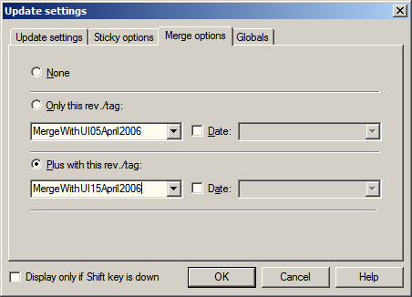

Resolve the conflicts (if any) and commit the files.

The Step 5 tells VSS to merge only the changes that have happened between 5th April and 15th April. The order of the Merge tag is very important; else the source code may get corrupted.

Baselining Process

Base line is defined as “a set of work products that has been formally reviewed and approved, that thereafter serves as a basis for further development and that can be changed only through formal Scope Change Management”. This can be achieved as per below specified approaches, and as per requirements, please select appropriate approach.
- Creating Tag
- Merging(collapsing) child node to root node and creating new branch

(The above two approaches are defined in sections 2.4, 2.5 and 2.8)

